**Hibernate Project**

* 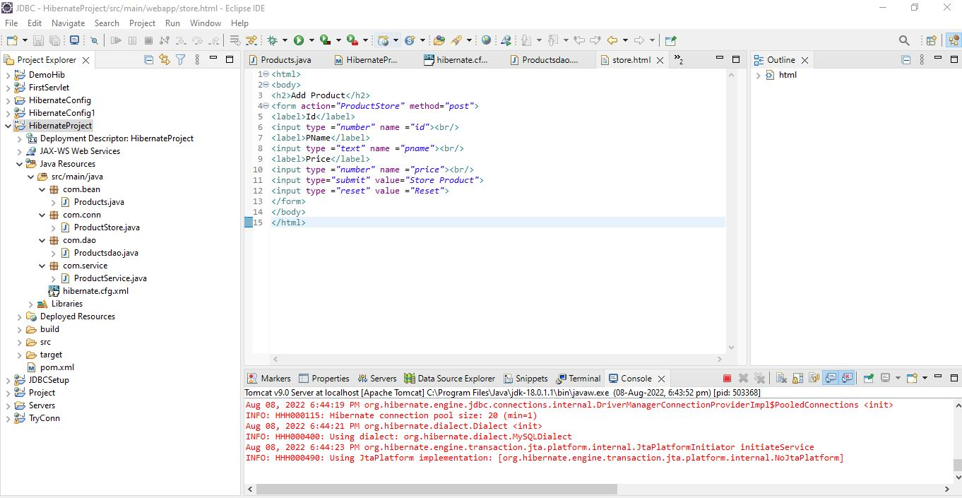Above is the eclipse code page where required packages are installed.

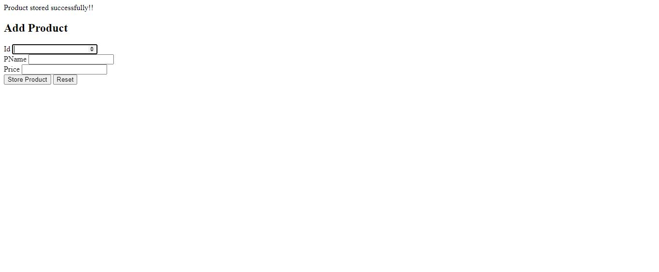

* Above is the user page where users are allowed to enter the details.
* Product id should be entered.
* Product name is entered.
* Price of the product is entered.
* Then user should click on store product to store the details.

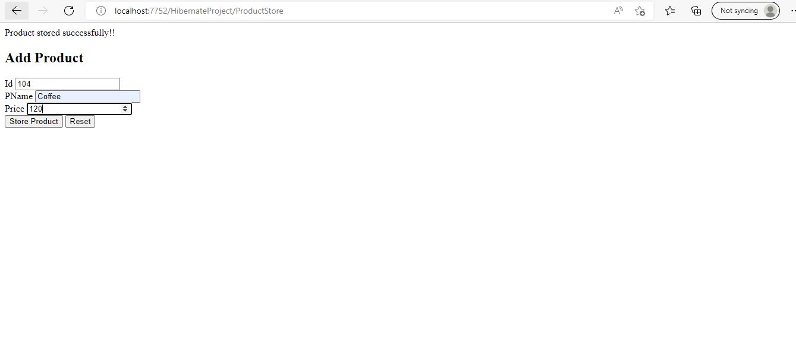

* Details are entered correctly in the fields.

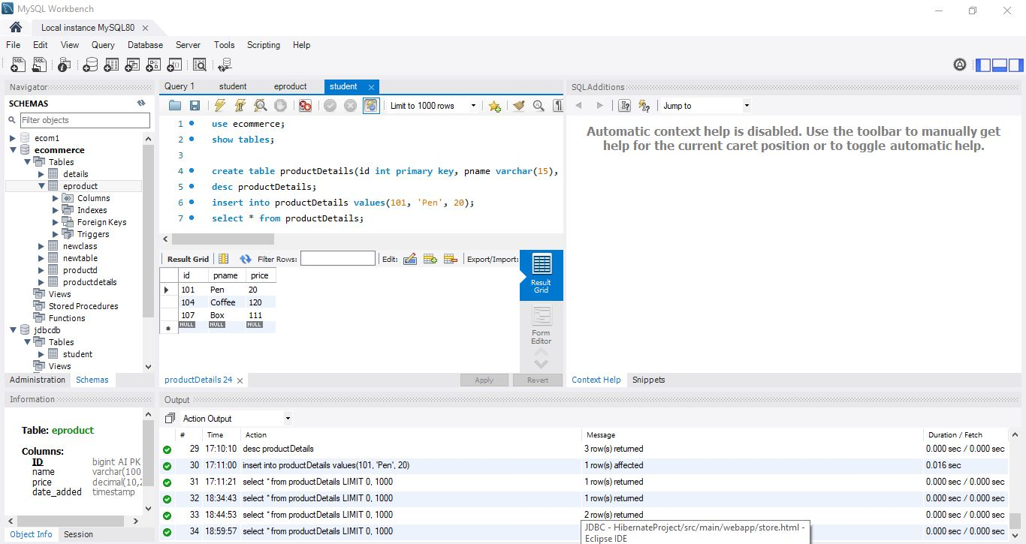

* This is the mysql workbench page.
* When the user page is added the data, it is reflected in the database